Reference Video for G Stretch

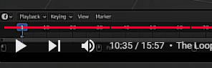

[The Video](https://www.youtube.com/watch?v=o4LopQs2bBQ#:~:text=if%20you%20have%20flatten%20selected%20it%27s%20going,and%20put%20them%20on%20the%20same%20plane.&text=so%20if%20you%20do%20need%20to%20create,to%20select%20a%20number%20of%20different%20vertices)

You will use a curve to use this tool.

